For your homework this week I would like you to follow the instructions below to create your own closed water cycle and then attach to a sunny window at home.
Pleased then record in the table below what you observe for the next 5 days and see if you can identify the part of the water cycle that you are observing.

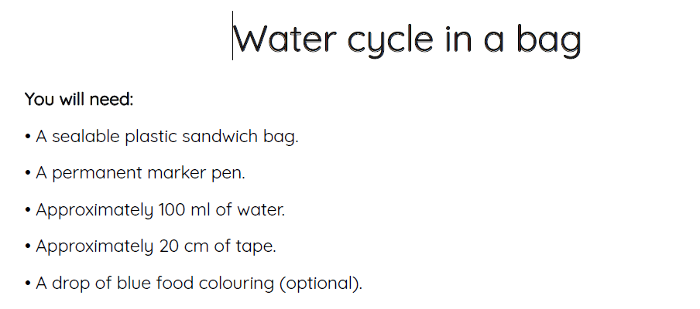

Instructions

- Use the marker pen to draw the water cycle on the bag.
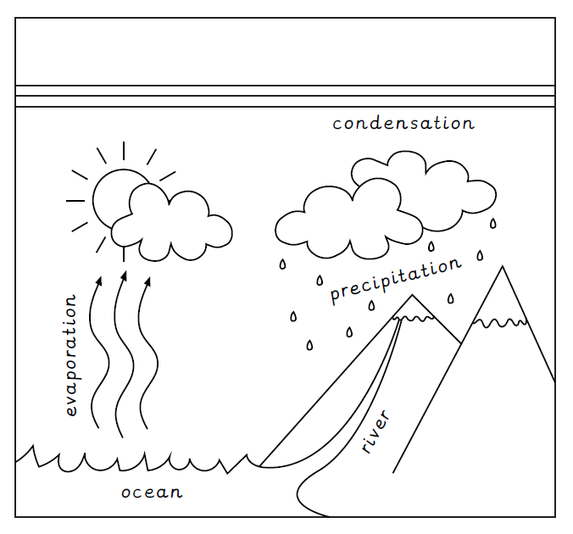
- Pour the water into the bag along with the blue food colouring.
- Seal the bag tightly and tape over the seal for extra security.
- Tape the bag to the window that receives the most sunlight.
- Record when and what you observe over the next 4 days.

Day | Time observed | What’s happening? | What part of the water cycle is it?
1
2
3
4

